Windows Server Template MOP

1. **Proxmox UI**
   1. Hardware Setup

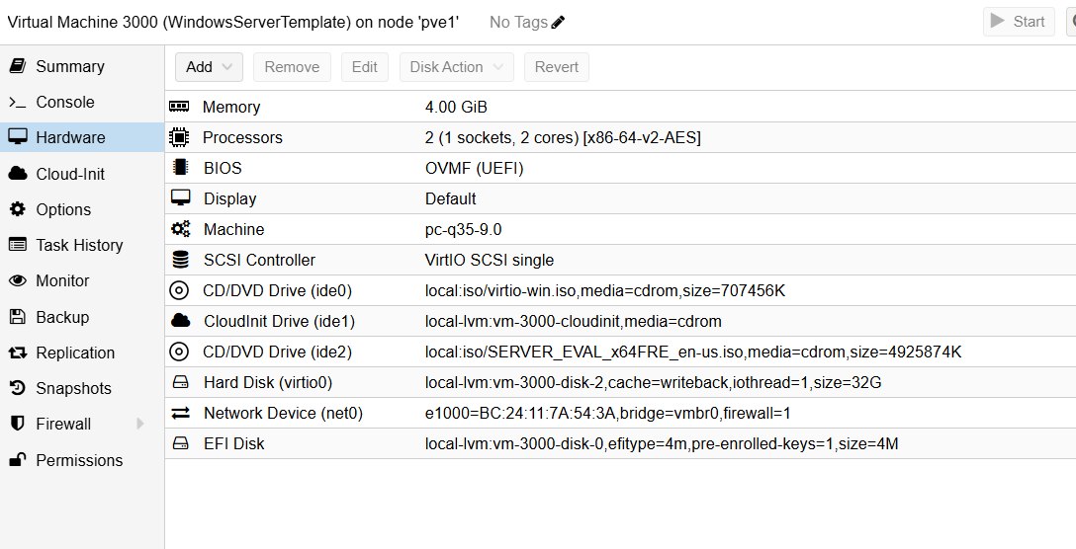

* 1. Cloud-Init Drive

Username, SSH public key, IP Config set to DHCP

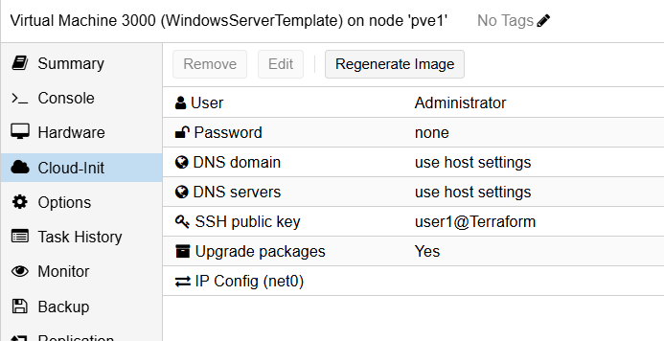

1. **Install MySql**
   1. **Download MySQL Installer**
      1. Go to [MySQLcommunity Downloads](https://dev.mysql.com/downloads/installer/)
      2. Download **MySQL Installer for Windows** (choose the **full** or **custom** version).
   2. **Install MySQL**
      1. Run the installer.
      2. Choose **Custom Installation** and select:
         1. **MySQL Server**
         2. **MySQL Workbench** (optional)
         3. **MySQL Shell**
   3. **Secure MySQL**
      1. Set root password.
         1. P@SSWORD!
      2. Allow localhost access only.
      3. Create a default database and user:
         1. Open **MySQL Shell**.
         2. \connect root@localhost
         3. \sql

CREATE DATABASE classdb;

CREATE USER 'classuser'@'localhost' IDENTIFIED BY 'P@SSWORD!';

GRANT ALL PRIVILEGES ON classdb.* TO 'classuser'@'localhost';

FLUSH PRIVILEGES;

SHOW DATABASES;

* 1. **Enable MySQL Service on Startup**

Powershell

* + 1. sc.exe config MySQL80 start= auto
    2. net start MySQL80

1. **Install QEMU Guest Agent**
   1. Make sure windows driver iso is mounted
   2. Go to Device Manager
   3. Find PCI Simple Communications Controller
   4. Right click then update driver
   5. On the iso driver vioserial -> 2k22 -> amd64
   6. Go to mounted driver iso in file explorer
   7. Click into folder guest-agent
   8. Double click qemu-ga-x86_64 to install
   9. Confirm its up by running command “Get-Service QEMU-GA" in powershell
2. Enable Powershell remoting
   1. Enable-PSRemoting –Force
3. Enable winrm on windows template
   1. winrm quickconfig -q
   2. winrm set winrm/config/winrs '@{MaxMemoryPerShellMB="512"}'
   3. winrm set winrm/config '@{MaxTimeoutms="1800000"}'
   4. winrm set winrm/config/service '@{AllowUnencrypted="true"}'
   5. winrm set winrm/config/service/auth '@{Basic="true"}'
   6. Set-Item -Path WSMan:\localhost\Service\AllowUnencrypted -Value $true
   7. Set-Item -Path WSMan:\localhost\Service\Auth\Basic -Value $true
4. Create Firewall rule
   1. New-NetFirewallRule – DisplayName “Allow Winrm HTTP” - Direction Inbound –LocalPort 5985 –Protocol TCP –Action Allow
5. Configure TrustedHosts
   1. Set-Item WSMan:\localhost\Client\TrustedHosts -Value “*” -Force
6. Set execution policy to unrestricted
   1. Set-ExecutionPolicy Unrestricted –Force
7. Restart Winrm
   1. Restart-Service WinRM
8. Set listener
   1. winrm enumerate winrm/config/Listener
9. **Run sysprep to prepare the system for conversion to a template**

Open command prompt

%WINDIR%\system32\sysprep\sysprep.exe /generalize /shutdown /oobe